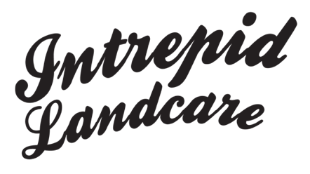
Photographic/video/audio material release form

I give permission for photographic/video/audio material of myself (or my child), to be taken with my consent by Intrepid Landcare at _______________________________(location) on ___/___/___ and used for a range of Intrepid Landcare films, website, and media promotions to help increase volunteer participation in managing our natural resources.
I understand Intrepid Landcare will retain copyright of the material and will maintain the integrity of the photographic/video/audio material and not allow its use in a derogatory treatment or context.

Signature________________________________________
Print name _________________________________________________
Phone ________________________________

To authorise use of audio material of your child or teenager under 18 years old, please complete the following:

Signed for ______________________________ Dated __/__/__

.

